**Output:-**

# **Name : Rajkumar B L**

# **Reg.No : 2047120**

# **Course : MCS 271 Data Structure (Lab 14 – Red Black Tree)**

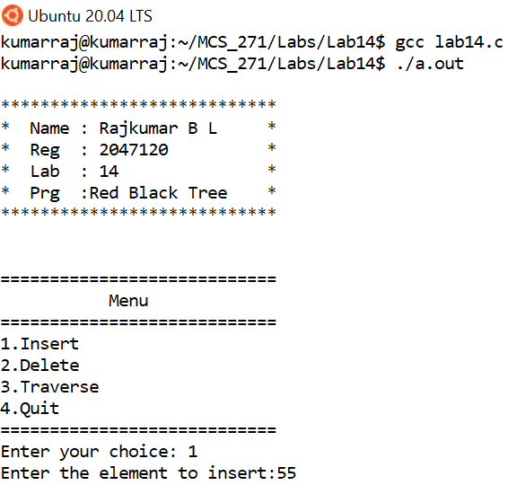

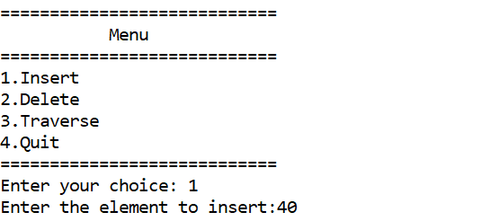

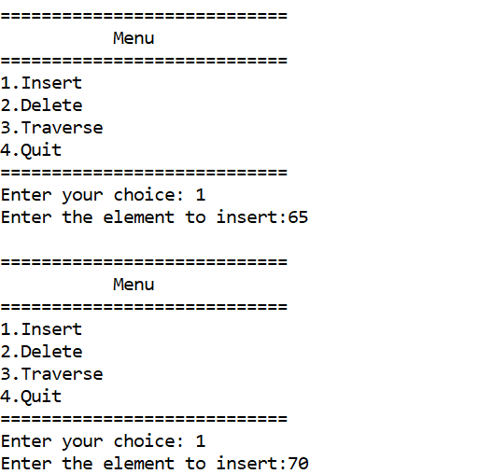

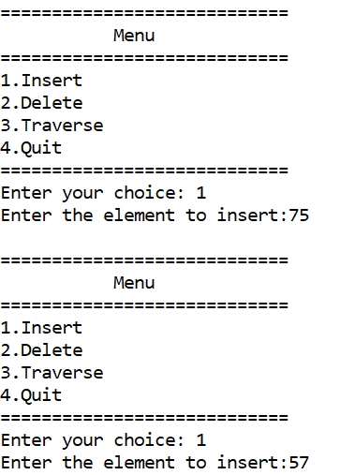

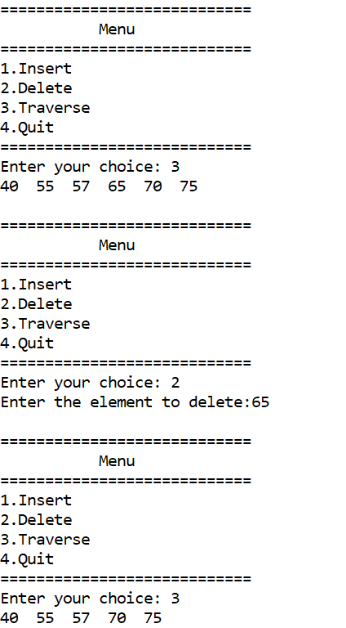

**Code:-**

/**********************

 * Name : Rajkumar B L

 * Reg  : 2047120

 * Lab  : 14

 * Program : Red Black Tree

 * ********************/

#include <stdio.h>

#include <stdlib.h>

enum nodeColor

{

    RED,

    BLACK

};

struct rbNode

{

    int data, color;

    struct rbNode *link[2];

};

struct rbNode *root = NULL;

// Create a red-black tree

struct rbNode *createNode(int data)

{

    struct rbNode *newnode;

    newnode = (struct rbNode *)malloc(sizeof(struct rbNode));

    newnode->data = data;

    newnode->color = RED;

    newnode->link[0] = newnode->link[1] = NULL;

    return newnode;

}

// Insert an node

void insertion(int data)

{

    struct rbNode *stack[98], *ptr, *newnode, *xPtr, *yPtr;

    int dir[98], ht = 0, index;

    ptr = root;

    if (!root)

    {

        root = createNode(data);

        return;

    }

    stack[ht] = root;

    dir[ht++] = 0;

    while (ptr != NULL)

    {

        if (ptr->data == data)

        {

            printf("Duplicates Not Allowed!!\n");

            return;

        }

        index = (data - ptr->data) > 0 ? 1 : 0;

        stack[ht] = ptr;

        ptr = ptr->link[index];

        dir[ht++] = index;

    }

    stack[ht - 1]->link[index] = newnode = createNode(data);

    while ((ht >= 3) && (stack[ht - 1]->color == RED))

    {

        if (dir[ht - 2] == 0)

        {

            yPtr = stack[ht - 2]->link[1];

            if (yPtr != NULL && yPtr->color == RED)

            {

                stack[ht - 2]->color = RED;

                stack[ht - 1]->color = yPtr->color = BLACK;

                ht = ht - 2;

            }

            else

            {

                if (dir[ht - 1] == 0)

                {

                    yPtr = stack[ht - 1];

                }

                else

                {

                    xPtr = stack[ht - 1];

                    yPtr = xPtr->link[1];

                    xPtr->link[1] = yPtr->link[0];

                    yPtr->link[0] = xPtr;

                    stack[ht - 2]->link[0] = yPtr;

                }

                xPtr = stack[ht - 2];

                xPtr->color = RED;

                yPtr->color = BLACK;

                xPtr->link[0] = yPtr->link[1];

                yPtr->link[1] = xPtr;

                if (xPtr == root)

                {

                    root = yPtr;

                }

                else

                {

                    stack[ht - 3]->link[dir[ht - 3]] = yPtr;

                }

                break;

            }

        }

        else

        {

            yPtr = stack[ht - 2]->link[0];

            if ((yPtr != NULL) && (yPtr->color == RED))

            {

                stack[ht - 2]->color = RED;

                stack[ht - 1]->color = yPtr->color = BLACK;

                ht = ht - 2;

            }

            else

            {

                if (dir[ht - 1] == 1)

                {

                    yPtr = stack[ht - 1];

                }

                else

                {

                    xPtr = stack[ht - 1];

                    yPtr = xPtr->link[0];

                    xPtr->link[0] = yPtr->link[1];

                    yPtr->link[1] = xPtr;

                    stack[ht - 2]->link[1] = yPtr;

                }

                xPtr = stack[ht - 2];

                yPtr->color = BLACK;

                xPtr->color = RED;

                xPtr->link[1] = yPtr->link[0];

                yPtr->link[0] = xPtr;

                if (xPtr == root)

                {

                    root = yPtr;

                }

                else

                {

                    stack[ht - 3]->link[dir[ht - 3]] = yPtr;

                }

                break;

            }

        }

    }

    root->color = BLACK;

}

// Delete a node

void deletion(int data)

{

    struct rbNode *stack[98], *ptr, *xPtr, *yPtr;

    struct rbNode *pPtr, *qPtr, *rPtr;

    int dir[98], ht = 0, diff, i;

    enum nodeColor color;

    if (!root)

    {

        printf("Tree not available\n");

        return;

    }

    ptr = root;

    while (ptr != NULL)

    {

        if ((data - ptr->data) == 0)

            break;

        diff = (data - ptr->data) > 0 ? 1 : 0;

        stack[ht] = ptr;

        dir[ht++] = diff;

        ptr = ptr->link[diff];

    }

    if (ptr->link[1] == NULL)

    {

        if ((ptr == root) && (ptr->link[0] == NULL))

        {

            free(ptr);

            root = NULL;

        }

        else if (ptr == root)

        {

            root = ptr->link[0];

            free(ptr);

        }

        else

        {

            stack[ht - 1]->link[dir[ht - 1]] = ptr->link[0];

        }

    }

    else

    {

        xPtr = ptr->link[1];

        if (xPtr->link[0] == NULL)

        {

            xPtr->link[0] = ptr->link[0];

            color = xPtr->color;

            xPtr->color = ptr->color;

            ptr->color = color;

            if (ptr == root)

            {

                root = xPtr;

            }

            else

            {

                stack[ht - 1]->link[dir[ht - 1]] = xPtr;

            }

            dir[ht] = 1;

            stack[ht++] = xPtr;

        }

        else

        {

            i = ht++;

            while (1)

            {

                dir[ht] = 0;

                stack[ht++] = xPtr;

                yPtr = xPtr->link[0];

                if (!yPtr->link[0])

                    break;

                xPtr = yPtr;

            }

            dir[i] = 1;

            stack[i] = yPtr;

            if (i > 0)

                stack[i - 1]->link[dir[i - 1]] = yPtr;

            yPtr->link[0] = ptr->link[0];

            xPtr->link[0] = yPtr->link[1];

            yPtr->link[1] = ptr->link[1];

            if (ptr == root)

            {

                root = yPtr;

            }

            color = yPtr->color;

            yPtr->color = ptr->color;

            ptr->color = color;

        }

    }

    if (ht < 1)

        return;

    if (ptr->color == BLACK)

    {

        while (1)

        {

            pPtr = stack[ht - 1]->link[dir[ht - 1]];

            if (pPtr && pPtr->color == RED)

            {

                pPtr->color = BLACK;

                break;

            }

            if (ht < 2)

                break;

            if (dir[ht - 2] == 0)

            {

                rPtr = stack[ht - 1]->link[1];

                if (!rPtr)

                    break;

                if (rPtr->color == RED)

                {

                    stack[ht - 1]->color = RED;

                    rPtr->color = BLACK;

                    stack[ht - 1]->link[1] = rPtr->link[0];

                    rPtr->link[0] = stack[ht - 1];

                    if (stack[ht - 1] == root)

                    {

                        root = rPtr;

                    }

                    else

                    {

                        stack[ht - 2]->link[dir[ht - 2]] = rPtr;

                    }

                    dir[ht] = 0;

                    stack[ht] = stack[ht - 1];

                    stack[ht - 1] = rPtr;

                    ht++;

                    rPtr = stack[ht - 1]->link[1];

                }

                if ((!rPtr->link[0] || rPtr->link[0]->color == BLACK) &&

                    (!rPtr->link[1] || rPtr->link[1]->color == BLACK))

                {

                    rPtr->color = RED;

                }

                else

                {

                    if (!rPtr->link[1] || rPtr->link[1]->color == BLACK)

                    {

                        qPtr = rPtr->link[0];

                        rPtr->color = RED;

                        qPtr->color = BLACK;

                        rPtr->link[0] = qPtr->link[1];

                        qPtr->link[1] = rPtr;

                        rPtr = stack[ht - 1]->link[1] = qPtr;

                    }

                    rPtr->color = stack[ht - 1]->color;

                    stack[ht - 1]->color = BLACK;

                    rPtr->link[1]->color = BLACK;

                    stack[ht - 1]->link[1] = rPtr->link[0];

                    rPtr->link[0] = stack[ht - 1];

                    if (stack[ht - 1] == root)

                    {

                        root = rPtr;

                    }

                    else

                    {

                        stack[ht - 2]->link[dir[ht - 2]] = rPtr;

                    }

                    break;

                }

            }

            else

            {

                rPtr = stack[ht - 1]->link[0];

                if (!rPtr)

                    break;

                if (rPtr->color == RED)

                {

                    stack[ht - 1]->color = RED;

                    rPtr->color = BLACK;

                    stack[ht - 1]->link[0] = rPtr->link[1];

                    rPtr->link[1] = stack[ht - 1];

                    if (stack[ht - 1] == root)

                    {

                        root = rPtr;

                    }

                    else

                    {

                        stack[ht - 2]->link[dir[ht - 2]] = rPtr;

                    }

                    dir[ht] = 1;

                    stack[ht] = stack[ht - 1];

                    stack[ht - 1] = rPtr;

                    ht++;

                    rPtr = stack[ht - 1]->link[0];

                }

                if ((!rPtr->link[0] || rPtr->link[0]->color == BLACK) &&

                    (!rPtr->link[1] || rPtr->link[1]->color == BLACK))

                {

                    rPtr->color = RED;

                }

                else

                {

                    if (!rPtr->link[0] || rPtr->link[0]->color == BLACK)

                    {

                        qPtr = rPtr->link[1];

                        rPtr->color = RED;

                        qPtr->color = BLACK;

                        rPtr->link[1] = qPtr->link[0];

                        qPtr->link[0] = rPtr;

                        rPtr = stack[ht - 1]->link[0] = qPtr;

                    }

                    rPtr->color = stack[ht - 1]->color;

                    stack[ht - 1]->color = BLACK;

                    rPtr->link[0]->color = BLACK;

                    stack[ht - 1]->link[0] = rPtr->link[1];

                    rPtr->link[1] = stack[ht - 1];

                    if (stack[ht - 1] == root)

                    {

                        root = rPtr;

                    }

                    else

                    {

                        stack[ht - 2]->link[dir[ht - 2]] = rPtr;

                    }

                    break;

                }

            }

            ht--;

        }

    }

}

// Print the inorder traversal of the tree

void inorderTraversal(struct rbNode *node)

{

    if (node)

    {

        inorderTraversal(node->link[0]);

        printf("%d  ", node->data);

        inorderTraversal(node->link[1]);

    }

    return;

}

int main()

{

    printf("\n****************************\n*  Name : Rajkumar B L     *\n*  Reg  : 2047120          *\n*  Lab  : 14               *\n*  Prg  :Red Black Tree    *\n****************************\n\n");

    int data;

    int choice;

    do

    {

        printf("\n============================\n\t   Menu\n============================\n");

        printf("1.Insert\n2.Delete\n3.Traverse\n4.Quit\n");

        printf("============================\n");

        printf("Enter your choice: ");

        scanf("%d", &choice);

        switch (choice)

        {

        case 1:

            printf("Enter the element to insert:");

            scanf("%d", &data);

            insertion(data);

            break;

        case 2:

            printf("Enter the element to delete:");

            scanf("%d", &data);

            deletion(data);

            break;

        case 3:

            inorderTraversal(root);

            printf("\n");

            break;

        case 4:

            printf("Bye!\n\n");

            exit(1);

        default:

            printf("Invalid Choice\n");

            break;

        }

    } while (choice != 5);

    return 0;

}